## **Part 1**

1. Run a query that creates a table named Authors that has the following columns: AuthorID, FullName, BirthCountry.
   * AuthorID is the primary key and auto increments.

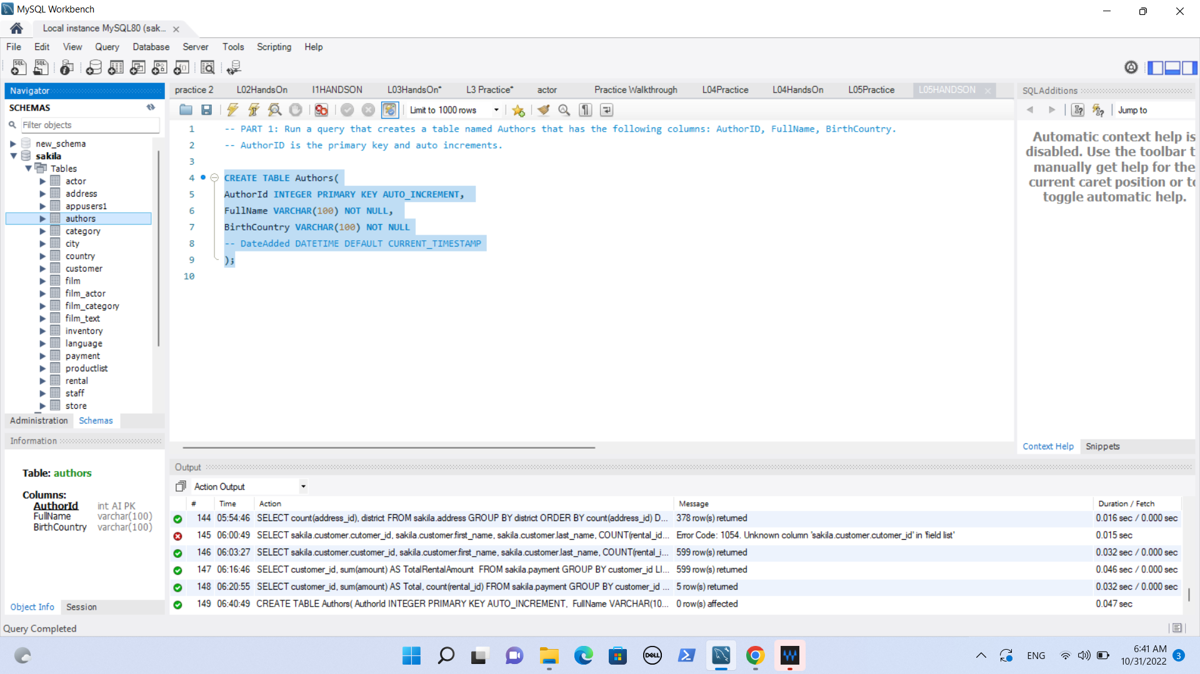

1. Add the following Authors table:

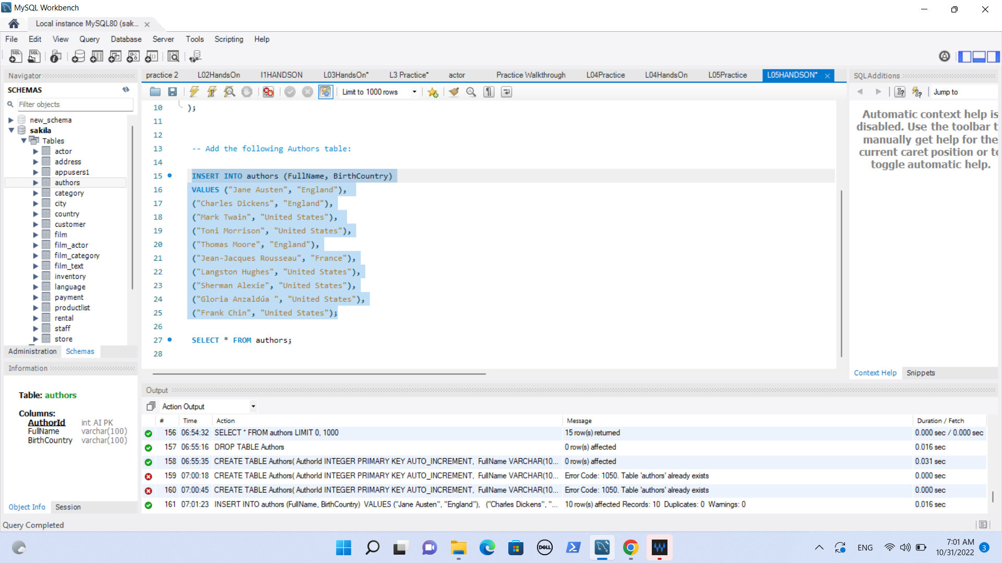

1. Run a query to see all of the authors within the database.

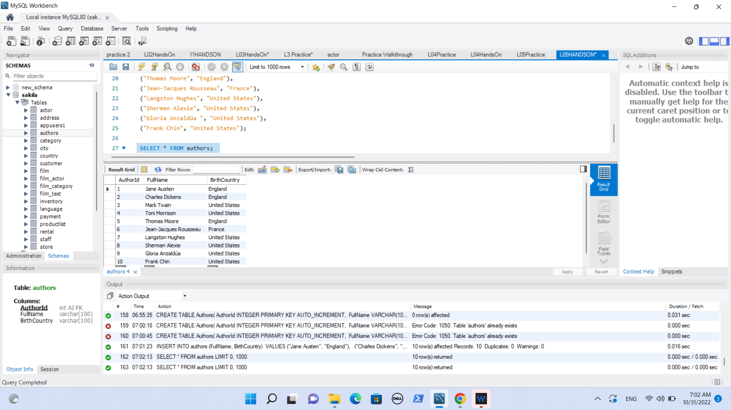

## **Part 2**

1. Run a query that creates a table named Books that has the following columns: BookID, Name, AuthorID.
   * BookID is the primary key and auto increments.
   * AuthorID is a foreign key that referenced the Authors table on the AuthorID column.

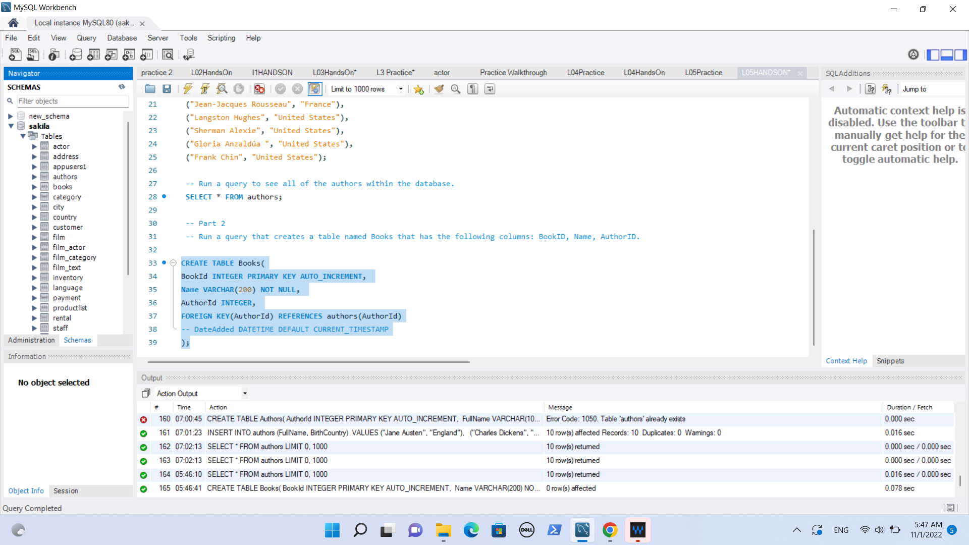

Add the following the Books table:

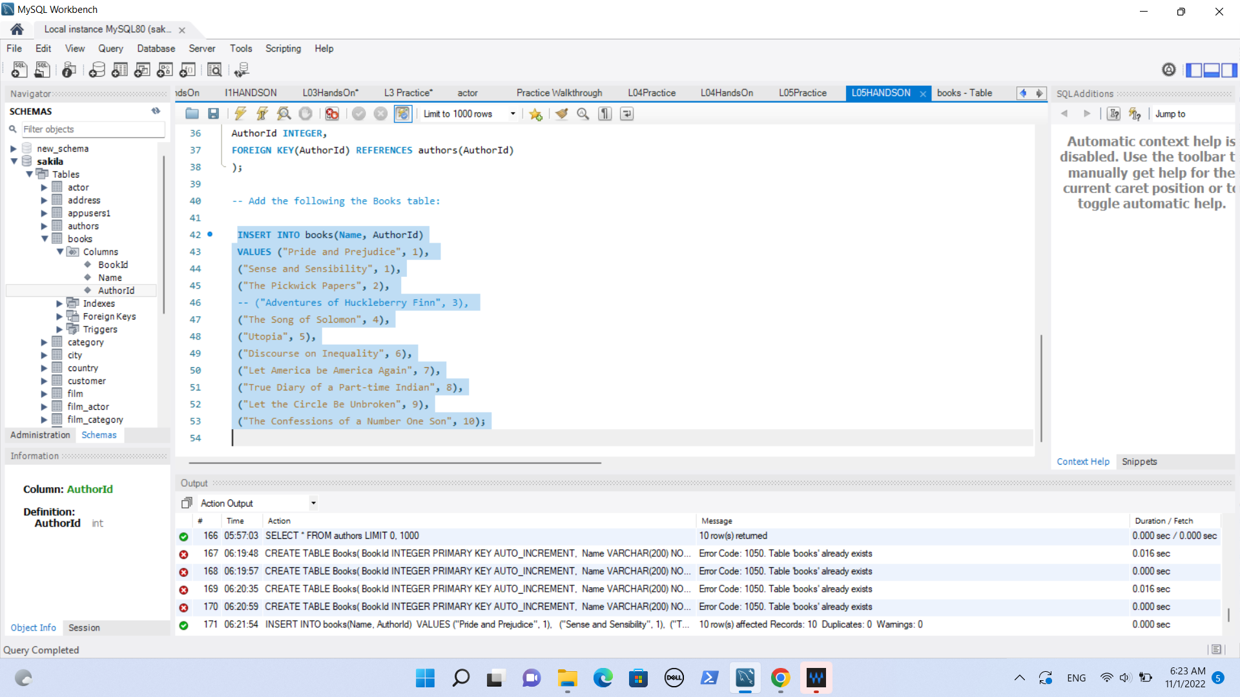

1. Run a query to see all of the books within the database.

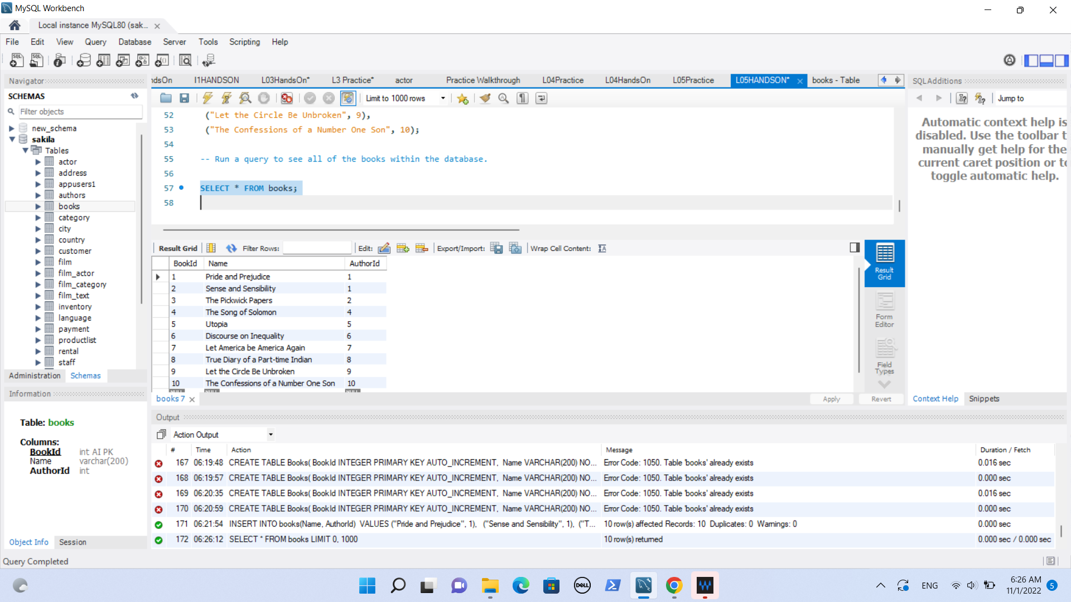

PART 3

